ACTIVATION FUNCTION
1.TANH
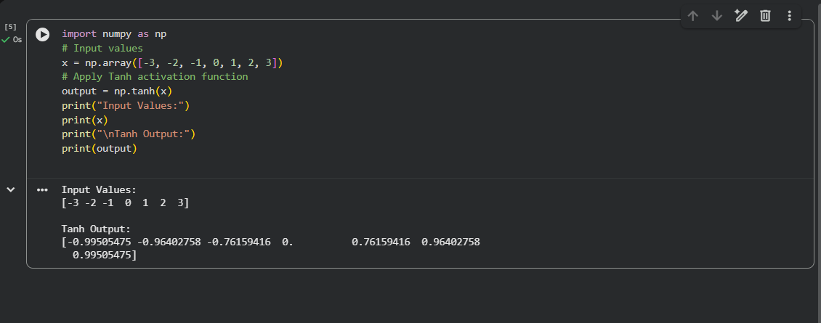
2. ReLu
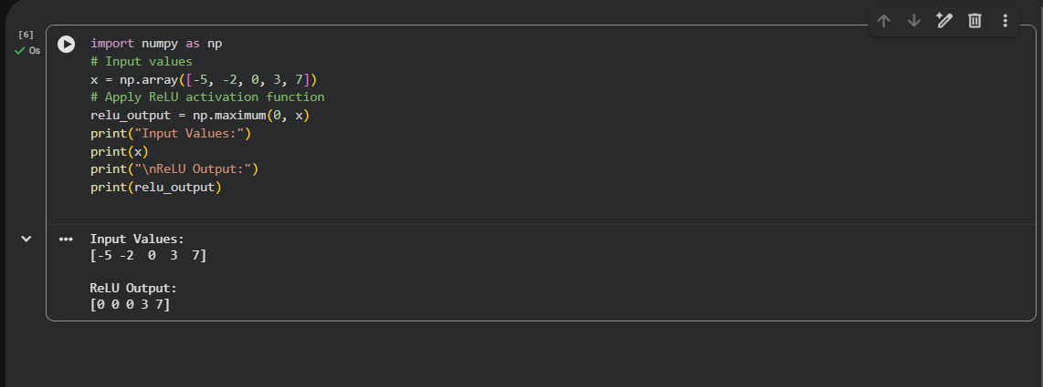
3. Sigmoid
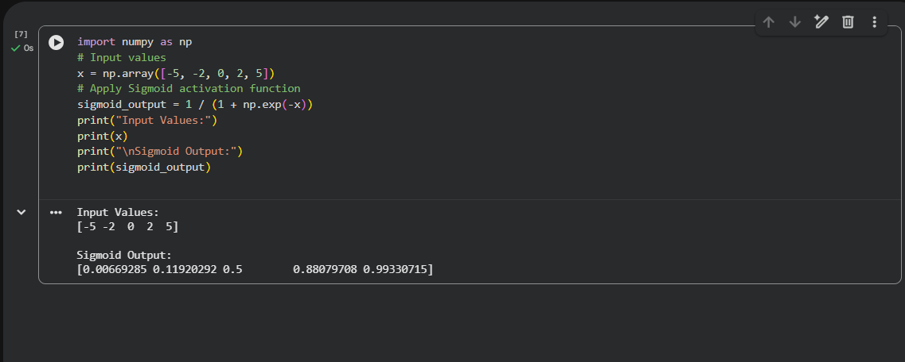
4. SOFTMAX
